**Experiment # 7**

**OBJECTIVE:**

To become familiar with Function and its declaration

To become familiar with pass by value and pass by reference

**Function:**

Function is named block of code that perform some action. The statement in the function is executed when it is called by its name. Each function has a unique name.

**Function declaration:**

return_type function_name( parameter list ) {

body of the function

}

**Where:**  
- return_type is the type of the value returned by the function.  
- function_name is the identifier by which the function can be called.  
- parameters list (as many as needed): Each parameter consists of a type followed by an identifier, with each parameter being separated from the next by a comma.

**Pass by Value:**

A parameter passing mechanism in which the value of actual parameter is copies to formal parameter of called function as pass by value.

**Example:**

#include <iostream>

using namespace std;

void max(int a, int b);

int main()

{

int x,y;

cout<<"Enter 1st number: ";

cin >> x;

cout<<"Enter 2nd number: ";

cin>>y;

max(x,y);

return 0;

}

void max(int a,int b){

if(a > b)

cout<<"Maximum number is "<<a;

else

cout<<"Maximum number is "<<b;

}

**OUTPUT:**

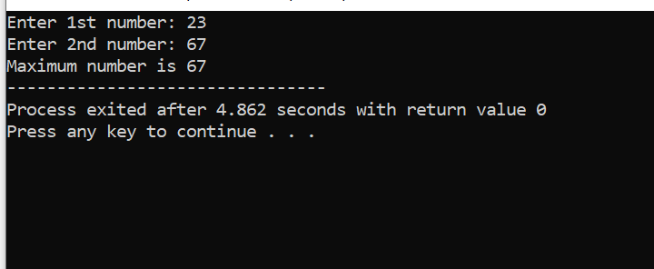

**Pass by Reference:**

A parameter passing mechanism in which the address of actual parameter is passed to the called function is known as pass by reference.

**Lab Tasks:**

QNo:01 Compile the program given in example and display its output.

QNo:02 Develop a program that explain the pass by reference mechanism.

**QUESTION NUMBER : 01:**

Compile the program given in example and display its output.

**PROGRAM:**

#include <iostream>

using namespace std;

void max(int a, int b);

int main()

{

int x,y;

cout<<"Enter 1st number: ";

cin >> x;

cout<<"Enter 2nd number: ";

cin>>y;

max(x,y);

return 0;

}

void max(int a,int b){

if(a > b)

cout<<"Maximum number is "<<a;

else

cout<<"Maximum number is "<<b;

}

**OUTPUT:**

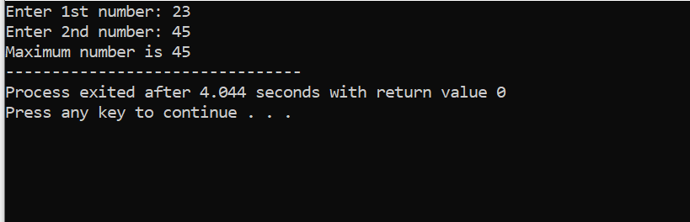

**QUESTION NUMBER : 02:**

Compile the program given in example and display its output.

**PROGRAM:**

#include <iostream>

using namespace std;

void swap(int &n1, int &n2) {

int temp;

temp = n1;

n1 = n2;

n2 = temp;

}

int main()

{

int a = 1, b = 2;

cout << "Before swapping" << endl;

cout << "a = " << a << endl;

cout << "b = " << b << endl;

swap(a, b);

cout << "\nAfter swapping" << endl;

cout << "a = " << a << endl;

cout << "b = " << b << endl;

return 0;

}

**OUTPUT:**

